


Savitribai Phule Pune University
A

Project Report
On
“Wildlife Amimal Sighting ”
Submitted in partial fulfillment of the requirement for the award of the degree of
MASTERS OF COMPUTER APPLICATION
[F.Y.MCA]
By

Sakshi Autade
Anjum Ansari
Akshada Gaikwad

Under the Guidance of
Prof. Suhas Nagori

At
Department of Masters of Computer Application SANDIP FOUNDATION’S
SANDIP INSTITUTE OF ENGINEERING &

MANAGEMENT Mahiravani, Trimbak Road Nashik-422213.




SANDIP FOUNDATION’S
SANDIP INSTITUTE OF ENGINEERING & MANAGEMENT

Mahiravani, Trimbak Road Nashik -422213.
Department of Masters of Computer Application

This is to certify that, the Project Entitled “wildlife Animal sighting” submitted by Sakshi Autade , Anjum Ansari , Akshada Gaikwad for partial fulfillment of the requirement for the award of the Masters of Computer Application at Sandip Institute of Engineering Management, Nashik as laid down by the Savitribai Phule Pune University. This is a record of the work carried out under my supervision and guidance during academic year 2024- 2025.
Place: - Nashik. Date: - / / 2025
Prof. Suhas Nagori (Dr). K. C. Nalavade Project Guide Vice principal

Dr.D.P.Patil Principal
Sandip Institute of Engineering and Management, Nashik

Acknowledgment

The Project report would not have been completed without the encouragement and support of many people who gave their precious time and encouragement throughout the period. First and foremost, I would like to express my deepest gratitude to my project guide Prof. Suhas Nagori for her invaluable support, guidance, motivation & encouragement throughout the period this work was carried out. His readiness for consultation at all times, his concern and assistance even with partial things has been extremely helpful. It was a great pleasure to work under his guidance.
I am also grateful to Dr. K. C. Nalavade Vice Principal (Sandip Institute of Engineering and Management) for her continuous motivation, support in all aspects and comments to improve my seminar.
I am most grateful to our honorable Principal Dr. D. P. Patil for giving me important comments to improve my Seminar. I sincerely thank to the entire team of staff members, and family and those who knowingly and unknowingly have contributed in their own way in completion of this seminar.

Sakshi Autade
Anjum Ansari Akshada Gaikwad

Abstract
Wildlife conservation requires timely and accurate information about species distribution and movement. Traditional methods of data collection are often slow, fragmented, and limited in coverage. The Wildlife Sighting Dashboard addresses these challenges by providing a centralized, digital platform for recording, managing, and analysing wildlife sightings.

The system enables real-time monitoring through interactive maps and visual reports, ensuring that researchers, forest officials, and conservationists can access reliable insights. By allowing community participation, the platform increases data availability and public awareness, supporting citizen science initiatives. Furthermore, the dashboard is designed using open-source technologies, making it cost-effective, scalable, and adaptable for future integration with advanced tools such as artificial intelligence and IoT devices.

Overall, this system offers an innovative approach to enhancing wildlife monitoring, promoting sustainable conservation, and bridging the gap between technology and environmental protection.

Index

Chapter | Topic | Page No.
 | Acknowledgment
 | Abstract
1 | Introduction
1.1 | Introduction
1.2 | Necessity
1.3 | Problem Statement
2 | Literature survey
2.1 | Existing Systems Survey
3 | System development
3.1 | Conclusion from Literature survey
3.2 | Proposed system Architecture
3.3 | Methodology for development
3.4 | Feasibility Study
4 | CODING
4.1 | Data Flow Diagram
4.2 | Use Case
4.3 | E-R Diagram
4.4 | Source Code
4.5 | Results
4.6 | Conclusion
4.7 | References

INTRODUCTION

  - Introduction
The Wildlife Sighting Dashboard is an interactive web-based platform designed to collect, manage, and analyze data on wildlife sightings within a specific region. The system enables users, including researchers, forest officials, and nature enthusiasts, to record detailed information about animal sightings, such as species name, location, date and time of observation, and additional remarks. By centralizing these records, the dashboard ensures that wildlife data is organized, accessible, and ready for analysis.
The platform provides visualization and analytical tools that allow users to explore wildlife data effectively. Using interactive maps powered by Leaflet.js, sightings can be displayed geographically, highlighting patterns of species distribution and frequently observed locations. Additionally, Plotly.js charts provide insights into trends, such as the frequency of species sightings over time, helping users monitor wildlife activity and identify potential anomalies or significant changes in population patterns.
The main objective of the Wildlife Sighting Dashboard is to provide a user-friendly and centralized tool for wildlife monitoring, supporting both research and conservation efforts. By visualizing real-time and historical sighting data, the system enables users to:
- Identify frequently sighted species.
- Detect trends and patterns in wildlife activity.
- Understand species distribution within the monitored region.

Key Features
- Data Collection & Management
Users can submit detailed wildlife sightings through a structured form. Each entry is stored systematically, allowing easy retrieval and review.
- Visualization Tools
Sightings are presented on interactive maps and in charts, making it easier to analyze trends, hotspots, and species distribution.
- Search & Filter Options
Users can filter sightings by species, date, or location, allowing focused exploration of the data.
- Reporting System
The dashboard can generate summary reports to support research, conservation planning, and monitoring of wildlife activity.
- Scalability
The platform is designed to be expandable, allowing future integration with IoT devices, GPS tracking, or AI-based monitoring.

Significance
The Wildlife Sighting Dashboard enhances data-driven wildlife monitoring by combining structured data collection with interactive visualization. It helps researchers and conservationists make informed decisions, fosters collaboration among stakeholders, and encourages community participation in biodiversity monitoring. By consolidating sighting data and providing analytical tools, the system promotes efficient conservation practices and contributes to better understanding of wildlife activity patterns.

  - Necessity

Wildlife plays a crucial role in maintaining ecological balance, yet human activities, urbanization, and climate change have significantly affected their natural habitats. Monitoring and protecting wildlife is becoming increasingly important to ensure biodiversity conservation and sustainable ecosystems. Traditional methods of tracking and recording wildlife sightings are often manual, time-consuming, and lack centralized storage, which makes data analysis and decision-making difficult.

The Wildlife Sighting Dashboard is necessary because:

- Centralized Data Management – It provides a single platform where researchers, forest officials, and enthusiasts can record and access wildlife sighting information.
- Real-Time Monitoring – Enables timely updates on animal movements, helping authorities take preventive measures in case of conflicts, poaching, or endangered species at risk.
- Data-Driven Insights – Visualization of trends and patterns supports scientific studies, conservation programs, and government policies.
- Public Participation – Encourages citizen reporting, thereby involving local communities in wildlife protection efforts.
- Conservation Support – Helps in identifying declining populations, migration patterns, and habitat use, which are essential for wildlife management and preservation.
In today’s era of digital transformation, a dashboard-based solution is not just beneficial but
essential for effective wildlife conservation, research, and sustainable ecosystem management.

Problem Statement
Wildlife monitoring is a critical component of biodiversity conservation, providing essential information on species distribution, population trends, and ecosystem health. Effective monitoring helps researchers, forest officials, and conservationists make informed decisions for species protection, habitat management, and conflict mitigation.
However, current wildlife monitoring practices are fragmented and inefficient, which limits the ability to collect, analyze, and utilize data effectively. Some of the key challenges include:
- Decentralized Data Collection
Sightings are often recorded in manual field notebooks, spreadsheets, or isolated databases maintained by different organizations or individuals. This fragmented approach makes it difficult to consolidate information, resulting in incomplete datasets that hinder comprehensive biodiversity assessments.
- Limited Accessibility of Information
Wildlife sighting data is not easily accessible in real time. Researchers, forest officials, and other stakeholders cannot quickly retrieve up-to-date information on species occurrences, location hotspots, or recent trends. This lack of timely access affects the ability to respond to conservation threats effectively.
- Poor Data Visualization and Analysis
Raw data stored in spreadsheets or static records lacks interactive visualizations, making it challenging to identify patterns, such as migration routes, population increases or declines, and high-risk areas for human-wildlife conflict. Without proper visualization, the data cannot support data-driven conservation strategies.
- Inefficient Monitoring and Reporting
Manual tracking and delayed reporting slow down the detection of urgent conservation issues, such as poaching incidents, habitat destruction, or sightings of endangered species. This delay reduces the effectiveness of preventive measures and conservation interventions.
- Lack of Community Engagement
Citizens, students, and nature enthusiasts often lack a platform to contribute sighting observations. Valuable information from local communities remains underutilized, limiting the breadth and richness of wildlife datasets.
- Challenges in Trend Analysis and Reporting
Consolidating sightings across multiple regions or species is cumbersome, and generating summary reports for research or conservation planning requires significant manual effort. This limits the ability of researchers and officials to track trends over time, identify high-priority areas, and make informed decisions.
The Need for a Centralized Solution
Given these challenges, there is a clear need for a centralized, interactive, and user-friendly platform that allows efficient collection, storage, and visualization of wildlife sighting data. The Wildlife Sighting Dashboard addresses these gaps by offering:
- A unified platform for recording sightings with all essential details (species, location, date/time, remarks).
- Interactive maps and charts for analyzing trends, spotting hotspots, and monitoring biodiversity.
- Search and filter capabilities for species, date ranges, or locations, making data retrieval simple.
- Community participation, allowing citizens and enthusiasts to contribute observations.
- Support for data-driven conservation, research analysis, and informed decision-making.
By resolving the issues of fragmented data, limited accessibility, and poor visualization, the Wildlife Sighting Dashboard enhances efficiency, promotes collaboration, and enables proactive wildlife management.

Literature survey

Existing Systems Survey
Several platforms currently support wildlife and biodiversity monitoring, each with specific features and limitations:
- eBird
A widely used citizen science platform focused on bird sightings. It provides species-specific maps and migration data, enabling birdwatchers and researchers to track populations and movement patterns. However, it is limited to birds and does not support observations for other wildlife species, restricting its utility for broader biodiversity monitoring.
- iNaturalist
A global platform that allows users to record observations of plants and animals. It encourages community participation and citizen science by validating species identifications through user contributions. While it provides some data visualization, it lacks advanced analytical tools and interactive dashboards that researchers need for trend analysis or comprehensive wildlife studies.
- Wildlife Insights
An AI-based platform that primarily focuses on camera trap data analysis. It uses machine learning to identify species automatically, which is highly efficient for research-grade data. However, it is unsuitable for manual or public sighting entries, limiting its accessibility to local communities or casual observers.
- Biodiversity Portals
Various regional and national portals provide species databases and distribution maps. While useful for reference, these portals are often fragmented, static, and less interactive, making it difficult to perform real-time monitoring or multi-species analysis.
Conclusion:
While existing systems contribute to wildlife monitoring, they lack a unified, real-time, and user-friendly platform that allows multi-species sightings, interactive visualization, and active community participation. The Wildlife Sighting Dashboard addresses these gaps by centralizing data, providing interactive maps and charts, and enabling citizen contributions, making wildlife monitoring more accessible, comprehensive, and actionable.

System development

  - Conclusion from Literature Survey
From the study of existing wildlife monitoring platforms and related research, it is evident that while several systems are available, most exhibit significant limitations. These limitations include restricted data accessibility, lack of interactive visualization, minimal public involvement, and high reliance on manual reporting. Many platforms are tailored for specific regions or species, making them unsuitable for broader, multi-species monitoring or scalable deployment.
The literature survey highlights the following key points:
- Limited Real-Time Visualization and Analysis
Although many systems allow basic data collection, they often lack interactive maps, charts, or analytical tools that enable users to identify trends, hotspots, or unusual patterns in wildlife activity.
- Minimal Public Participation
Citizen contributions, which can greatly expand data coverage and accuracy, are often missing. This reduces the scope for community-driven conservation initiatives and limits engagement from nature enthusiasts or local communities.
- Restricted Integration of Geographical and Analytical Tools
Most existing platforms do not fully integrate geospatial mapping, trend analysis, and automated reporting, preventing efficient monitoring and decision-making.
- Lack of a Centralized, User-Friendly Solution
There is a clear need for a scalable and easy-to-use dashboard that can be used by researchers, forest departments, NGOs, and the general public, allowing comprehensive wildlife monitoring in a single platform.
Conclusion:
The survey demonstrates a significant gap in current wildlife monitoring solutions. Existing platforms fail to provide a centralized, real-time, and interactive system that supports multi-species sightings, data visualization, community participation, and decision-support features. This gap establishes the necessity for the Wildlife Sighting Dashboard, which aims to address these limitations by combining data collection, visualization, analytics, and public engagement into a unified and accessible platform.

Proposed System Architecture

Overview

The Wildlife Sighting Dashboard will follow a modular, layered client–server architecture that supports web and mobile clients, a RESTful backend, a geospatial-aware database, and an analytics/visualization layer. The design emphasizes real-time ingestion of sightings, secure role- based access, spatial querying (maps/heatmaps), and extensibility for camera-trap / IoT integrations and AI-based species identification.

High-level components

    - User Interfaces
      - Web dashboard (researchers, officials, admins) — responsive UI, charts, maps, report builder.
      - Mobile/web form (citizen scientists / rangers) — submit sightings with GPS, photos, notes.
      - Admin panel — user management, data validation, system settings.

API / Backend
      - RESTful (or GraphQL) API layer to accept sightings, queries, authentication, and exports.
      - Business logic for validation, duplicate detection, notifications, and analytics jobs.
      - Species-identification microservice (optional) — image processing + ML model for auto ID.

Database & Storage
      - Relational DB with geospatial support (recommended: PostgreSQL + PostGIS). If you must use SQLite, keep in mind geospatial features are limited — SQLite + SpatiaLite is an alternative for lightweight setups.
      - Object storage for photos/media (cloud bucket or file server).
      - Caching layer (Redis) for frequently used queries (top species, hot zones).

Visualization & GIS
      - Map server or web mapping libraries (Leaflet / OpenLayers) and tile layers.
      - Charting libraries for time-series, bar charts, pie charts (e.g., Chart.js, Recharts).

Integrations
      - Camera-trap ingestion (batch upload), GPS trackers, IoT sensors.
      - External datasets (e.g., protected area polygons, species list APIs).
      - Notification channels (email, SMS, push).

Security & Ops
      - Authentication (JWT / OAuth2) and role-based authorization (admin, researcher, public).
      - HTTPS, input validation, rate limiting, logging and audit trails.
      - Backup strategy, automated tests, CI/CD pipeline, monitoring (Prometheus/Grafana).

  - Methodology for Development

The development of the Wildlife Sighting Dashboard follows a systematic software engineering approach to ensure that the system is efficient, reliable, and user-friendly. The methodology adopted is based on the Software Development Life Cycle (SDLC) with iterative improvements, ensuring that feedback from stakeholders such as researchers, forest officials, and end-users is continuously incorporated.

Requirement Analysis
  - Gather functional requirements (sighting submission, species database, visualization, reporting).
  - Identify non-functional requirements (performance, scalability, security, usability).
  - Consult domain experts (wildlife researchers, NGOs) to ensure the system addresses real- world needs.

System Design
  - Design system architecture with separate modules for user interface, backend services, database, and visualization tools.
  - Create UML diagrams (Use Case, Data Flow Diagram, ER Diagram) to define data and process flows.
  - Decide technology stack (Java/JSP, HTML/CSS/Bootstrap, JavaScript, PostgreSQL/SQLite, Tomcat server).

Implementation
  - Develop the system in modules (frontend UI, backend logic, database integration, visualization).
  - Implement secure authentication and role-based access (admin, researcher, citizen user).
  - Integrate mapping tools (Leaflet/Google Maps API) and chart libraries for data visualization.

Testing
  - Perform Unit Testing on each module.
  - Conduct Integration Testing to ensure smooth interaction between modules.
  - Carry out System Testing for overall functionality.
  - Run User Acceptance Testing (UAT) with a small group of users to validate usability and performance.

Deployment
  - Deploy the system on a Tomcat server for web hosting.
  - Configure the database (PostgreSQL/SQLite) and integrate with backend APIs.
  - Ensure the dashboard is accessible on web and mobile devices.

Maintenance & Future Enhancements
  - Provide regular updates, bug fixes, and security patches.
  - Enhance features such as AI-based species recognition, IoT sensor integration, and mobile app support.
  - Allow scalability to handle larger datasets and broader geographic coverage.

  - Feasibility Study

The Wildlife Sighting Dashboard is feasible in all respects:

    - Technical Feasibility – Uses open-source tools like Java, JSP, PostgreSQL/SQLite, Leaflet, and Chart.js, making development simple and scalable without special hardware.
    - Operational Feasibility – Easy-to-use interface with role-based access ensures smooth adoption by researchers, forest officials, and citizens.
    - Economic Feasibility – Development and maintenance costs are low, while long-term benefits include efficient wildlife monitoring and reduced manual efforts.

System Architecture

  - Data Flow Diagram

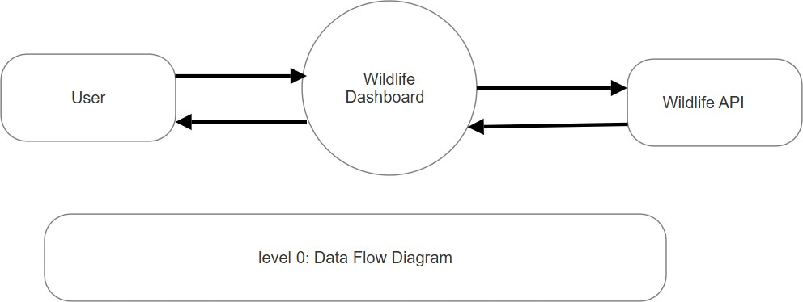

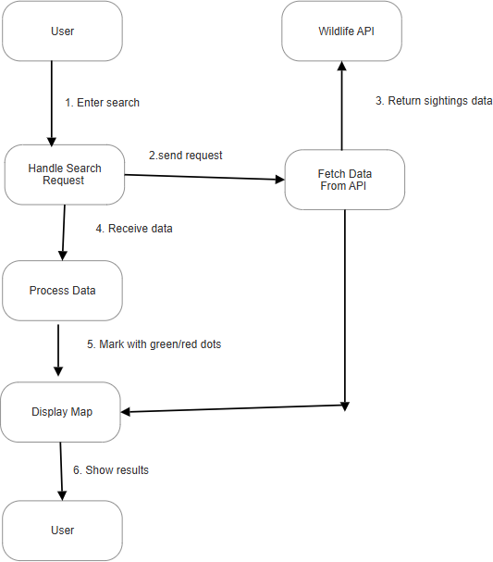

Level 1: data flow diagram

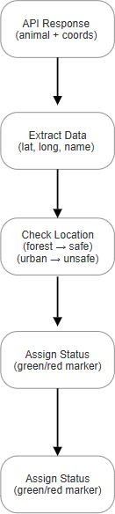

Level 2: data flow diagram

  - Use Case : -

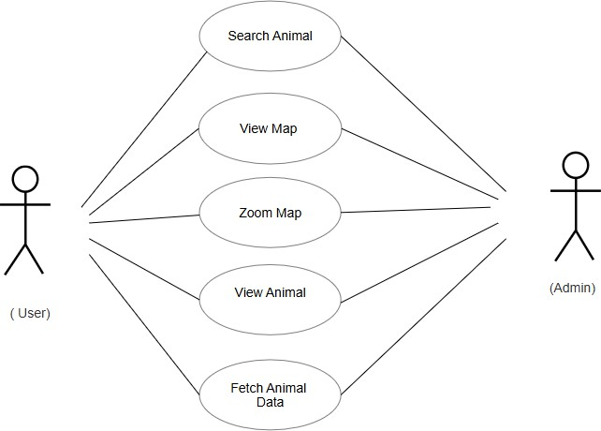

  - E-R Diagram

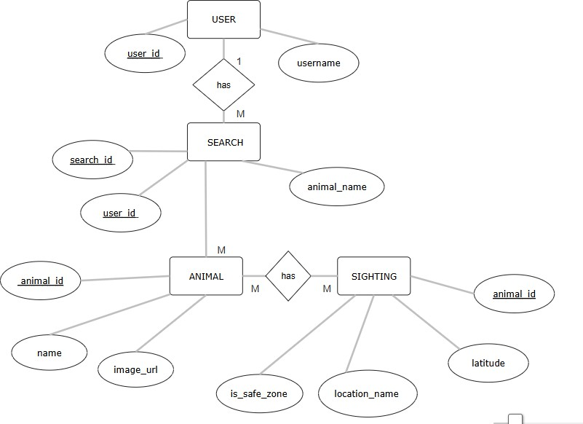

  - Data Dictionay :-

Data Element | Description | Type | Source / Destination
Animal_ID | Unique identifier for each animal entry | Integer | Wildlife Database
Animal_Name | Name of the animal (e.g., Tiger, Elephant) | String | User Input / Database
Area_Name | Name of the area/city where sighting occurs | String | User Input
Coordinates | Latitude & Longitude of sighting location | Float (Lat, Long) | Database → Map Service
Zone_Status | Indicates safety status: "Safe" or "Not Safe" | String (Enum) | Database → Map Display
Marker_Color | Visual indicator on map (Green = Safe, Red = Not Safe) | String (Color Code) | System (Map Service)
Sighting_Date | Date when the animal was sighted | Date | Database
Image_URL | Link to the image of the animal | String (Path/URL) | Wildlife Database
Map_View | Interactive map displayed to the user | Object (Map Tile) | Map Service
Zoom_Level | Level of zoom applied to the map | Integer | User Action → Map Service
Detailed_View | High-resolution map + animal image on zoom | Object | Map Service + Database
Search_Input | User’s search query (Animal Name + Area) | String | User
Search_Result | Retrieved data (animal info, image, zone, coordinates) | Object | System → User

  - Source Code

from flask import Flask, render_template, jsonify, request import requests
import pandas as pd import json
import os

app = Flask(_name_)

# ---------------------------

# User submissions file # ---------------------------
USER_FILE = "user_sightings.json" if not os.path.exists(USER_FILE):
with open(USER_FILE, "w") as f: json.dump([], f)

# ---------------------------

# Routes

# ---------------------------

@app.route("/") def index():
return render_template("index.html")

@app.route("/get_sightings") def get_sightings():
species = request.args.get("species", "").strip() url = "https://api.inaturalist.org/v1/observations" params = {"per_page": 100, "geo": True}
if species:

params["taxon_name"] = species

sightings = []

try:

r = requests.get(url, params=params, timeout=8) r.raise_for_status()
data = r.json().get("results", [])

for obs in data:

gj = obs.get("geojson")

if not gj or "coordinates" not in gj: continue
lng, lat = gj["coordinates"] sightings.append({
"name": obs.get("species_guess", "Unknown"), "lat": lat,
"lng": lng,

"observer": obs.get("user", {}).get("name", "Unknown"), "date": obs.get("observed_on", "Unknown"),
"image": obs.get("photos")[0]["url"] if obs.get("photos") else
None

})

except Exception: sightings = [
{"name": "Tiger", "lat": 28.7041, "lng": 77.1025, "observer":
"Admin", "date": "2025-01-01", "image": None},

{"name": "Leopard", "lat": 19.0760, "lng": 72.8777, "observer":
"Admin", "date": "2025-01-01", "image": None},

{"name": "Elephant", "lat": 13.0827, "lng": 80.2707, "observer":
"Admin", "date": "2025-01-01", "image": None},

]

# Add user sightings try:
if os.path.exists(USER_FILE):

with open(USER_FILE, "r") as f: user_sightings = json.load(f)
for s in user_sightings: sightings.append({
"name": s.get("name"),

"lat": s.get("lat"),

"lng": s.get("lng"), "observer": "User",
"date": "N/A",

"image": s.get("image", None)

})

except Exception: pass
return jsonify(sightings)

@app.route("/submit_sighting", methods=["POST"]) def submit_sighting():
data = request.get_json() if not data:
return jsonify({"message": "No data received"}), 400

try:
with open(USER_FILE, "r") as f: sightings = json.load(f)

sightings.append(data)

with open(USER_FILE, "w") as f: json.dump(sightings, f, indent=2)
return jsonify({"message": "Sighting submitted successfully!"}) except Exception as e:
return jsonify({"message": f"Error saving sighting: {str(e)}"}), 500

@app.route("/get_species_image") def get_species_image():
species = request.args.get("species", "").strip() if not species:
return jsonify({"image": None})

url = "https://api.inaturalist.org/v1/observations"

params = {"per_page": 1, "taxon_name": species, "geo": True}

try:

r = requests.get(url, params=params, timeout=8) r.raise_for_status()
data = r.json().get("results", [])

if data and data[0].get("photos"): image_url = data[0]["photos"][0]["url"] return jsonify({"image": image_url})
else:

return jsonify({"image": None}) except Exception:
return jsonify({"image": None})

# ---------------------------

# Dash integration at /dash/ # ---------------------------
def fetch_observations_df(species: str) -> pd.DataFrame: url = "https://api.inaturalist.org/v1/observations" params = {"per_page": 200, "geo": True}
if species:

params["taxon_name"] = species

try:

r = requests.get(url, params=params, timeout=10) r.raise_for_status()
data = r.json().get("results", []) rows = []
for obs in data:

gj = obs.get("geojson")

if not gj or "coordinates" not in gj: continue
lng, lat = gj["coordinates"]

rows.append({"name": obs.get("species_guess", "Unknown"), "lat": lat, "lng": lng})
return pd.DataFrame(rows) except Exception:
return pd.DataFrame([

{"name": "Tiger", "lat": 28.7041, "lng": 77.1025},

{"name": "Leopard", "lat": 19.0760, "lng": 72.8777},

{"name": "Elephant", "lat": 13.0827, "lng": 80.2707},

])

def create_dash_app(flask_app): import dash
from dash import html, dcc, Input, Output, State import plotly.express as px

dash_app = dash.Dash(

_name_, server=flask_app,
url_base_pathname="/dash/", suppress_callback_exceptions=True, title="Wildlife Analytics",
)

dash_app.layout = html.Div(

style={"maxWidth": "1100px", "margin": "0 auto", "padding": "12px"},
children=[

html.H2("Wildlife Analytics (Dash + Plotly)"), html.Div([
dcc.Input( id="species-input", type="text",
placeholder="Enter species (e.g., tiger, koala)", value="tiger",
style={"width": "60%", "padding": "8px"}

),

html.Button("Update", id="update-btn", n_clicks=0, style={"marginLeft": "8px", "padding": "8px 16px"}),
html.A(" ↩ Back to Dashboard", href="/", style={"marginLeft":
"16px"})

], style={"marginBottom": "12px"}),

dcc.Loading( type="default", children=[
dcc.Graph(id="map-fig"), dcc.Graph(id="count-fig"), dcc.Graph(id="trend-fig"),
]

),

html.Div(id="data-note", style={"fontSize": "12px", "color": "#666"})
]

)

@dash_app.callback( [Output("map-fig", "figure"),
Output("count-fig", "figure"),

Output("trend-fig", "figure"),

Output("data-note", "children")],

[Input("update-btn", "n_clicks")],

[State("species-input", "value")]

)

def refresh(n, species):

df = fetch_observations_df(species)

fig_map = px.scatter_mapbox(df, lat="lat", lon="lng", text="name", zoom=3, height=500)
fig_map.update_layout(mapbox_style="open-street-map")

counts = df["name"].value_counts().reset_index() counts.columns = ["name", "count"]
fig_count = px.bar(counts.head(15), x="name", y="count", title="Top Observed Species")

df["date"] = pd.date_range(end=pd.Timestamp.today(), periods=len(df))
fig_trend = px.line(df, x="date", y=df.groupby("date").cumcount(), title="Sightings Trend Over Time")

note = f"Showing {len(df)} observations (API + fallback)." return fig_map, fig_count, fig_trend, note

return dash_app

# Create Dash app create_dash_app(app)

if _name_ == "_main_": app.run(debug=True)
4.5 Result

Home page:
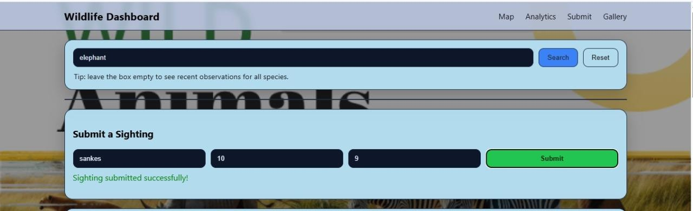

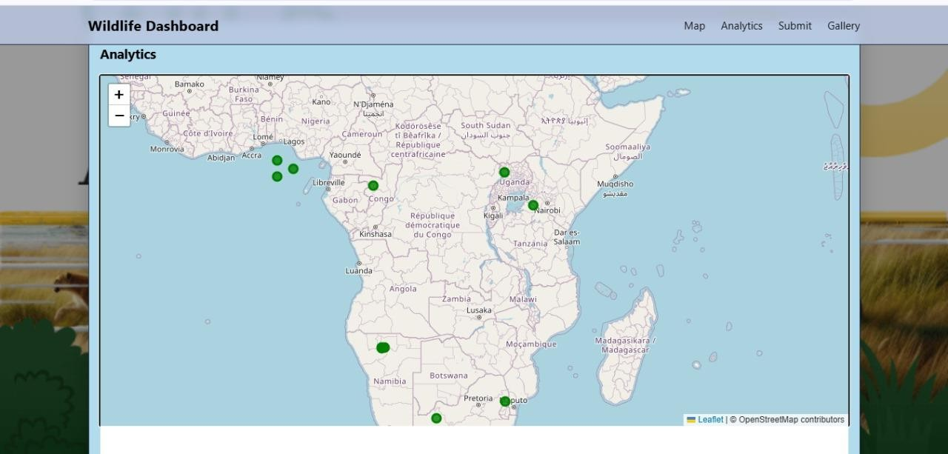
Map :

Bar Graph:
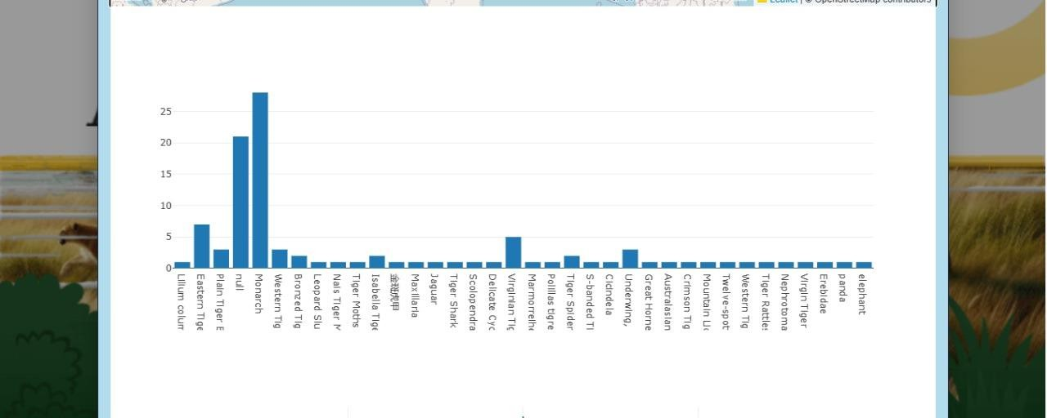

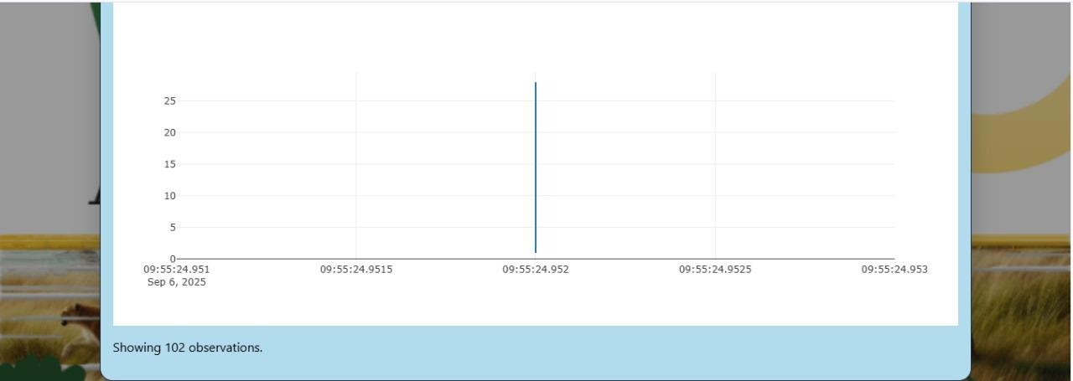
Time :-

Animal Gallery:

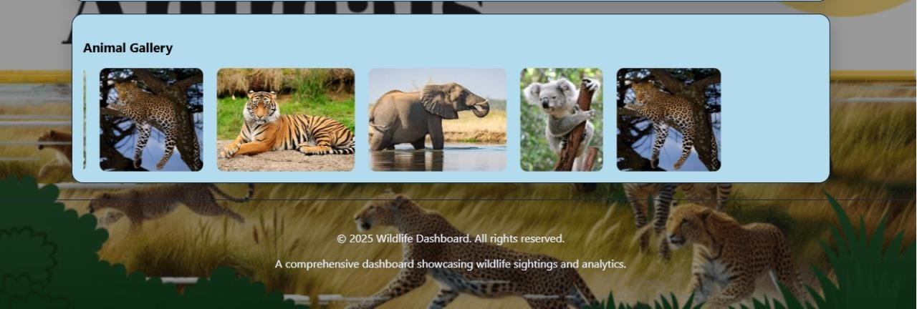

4.6 Conclusion

The Wildlife Sighting Dashboard successfully integrates real-time data with visualization techniques to provide an engaging and informative platform. It encourages both researchers and the public to contribute to wildlife monitoring. The system demonstrates how data + visualization + citizen participation can support biodiversity conservation.

4.7 References
- Greek – for historical background
- GitHub – for code repositories and libraries
- Python Book – for Python programming concepts
- Leaflet.js – for interactive map implementation
- Plotly.js – for chart and data visualization
- eBird – for wildlife monitoring reference
- iNaturalist – for citizen science reference
- Wildlife Insights – for AI-based wildlife monitoring

